Project work

Boat lifestyle



Comprehensive Digital marketing for boat life style:

BoAt Lifestyle, a leading brand in the consumer electronics industry, has built a strong reputation for its innovative audio products. To propel its growth further in the digital realm, a comprehensive digital marketing strategy is essential. Leveraging various digital platforms including social media, search engines, and e-commerce channels, BoAt Lifestyle can engage with its target audience on a deeper level. Through strategic content marketing initiatives such as blog posts, videos, and interactive campaigns, the brand can showcase the unique features and benefits of its products while also establishing itself as a thought leader in the audio industry. Additionally, personalized email marketing campaigns can help nurture customer relationships and drive repeat purchases, while influencer partnerships can amplify brand visibility and credibility among relevant audiences.

Moreover, optimizing the brand's website for search engines and implementing targeted advertising campaigns can enhance its online visibility and drive traffic to both its e-commerce platform and physical retail stores. Embracing emerging technologies such as augmented reality (AR) and virtual reality (VR) can provide consumers with immersive experiences, allowing them to interact with BoAt Lifestyle products virtually before making a purchase. By continuously analyzing data and metrics, the brand can refine its digital marketing efforts to ensure maximum ROI and stay ahead of competitors in the ever-evolving digital landscape. Through a holistic digital marketing approach, BoAt Lifestyle can solidify its position as a market leader and continue to delight customers with its cutting-edge audio solutions.

Those are the essential components of a strong marketing strategy! Let's break down each one:

1. Brand Study

\* What is your brand's unique selling proposition (USP)? What makes your boat lifestyle brand stand out from the competition?

\* What are your brand values? What do you stand for? What kind of experience do you want to create for your customers?

\* What is your brand voice and tone? How do you want to communicate with your audience? Is it casual, professional, fun, or luxurious?

\* What is your brand's visual identity? This includes your logo, color palette, fonts, and imagery. Make sure your visual identity is consistent across all of your marketing materials.

2. Competitor Analysis

\* Who are your main competitors? Identify the other brands that are targeting the same audience as you.

\* What are their strengths and weaknesses? What are they doing well? What could they be doing better?

\* What are their pricing strategies? How do their prices compare to yours?

\* What are their marketing channels? Where are they advertising? What kind of content are they creating?

3. Buyer's/Audience's Persona

\* Create detailed profiles of your ideal customers. Include their demographics, interests, hobbies, pain points, and motivations.

\* What are their needs and desires? What are they looking for in a boat lifestyle brand?

\* Where do they spend their time online? What social media platforms do they use? What websites do they visit?

Once you have a strong understanding of these three areas, you can start to develop a marketing strategy that is tailored to your brand and your target audience.

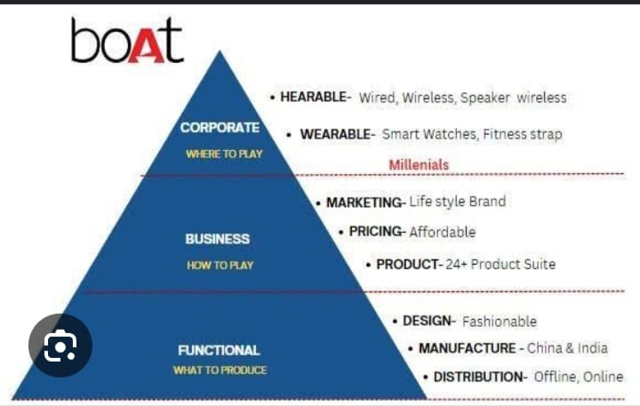

1. Analyze Your Competitors:

\* Visual Identity: Look at their logos, color palettes, fonts, and imagery. What kind of feeling do they evoke?

\* Messaging: What is their brand voice and tone? What kind of language do they use?

\* Values: What are their core values? What do they stand for?

2. Explore Your Target Audience:

\* Lifestyle: What kind of lifestyle do your ideal customers live? What are their interests and hobbies?

\* Values: What are their core values? What do they look for in a brand?

\* Aspirations: What do they aspire to? What kind of experience are they looking for?

3. Brainstorm Ideas:

\* Brand Name: Think of names that are memorable, relevant, and unique.

\* Logo: Create a logo that is visually appealing and represents your brand's values.

\* Color Palette: Choose colors that evoke the right emotions and reflect your brand's personality.

\* Fonts: Select fonts that are easy to read and reflect your brand's tone.

\* Imagery: Use high-quality images that capture the essence of your brand and lifestyle.

4. Develop a Brand Style Guide:

\* Create a document that outlines your brand's visual identity and messaging.

\* This guide should be used as a reference for all of your marketing materials.

5. Get Feedback:

\* Share your brand identity ideas with your target audience and get their feedback.

\* Make adjustments based on their feedback.

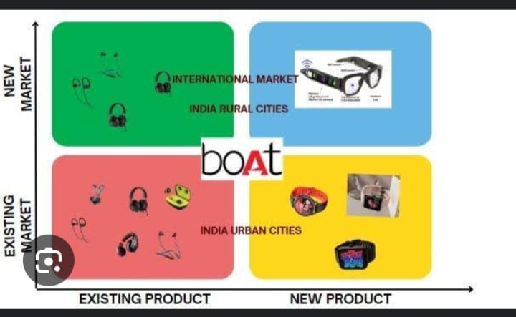

1. Direct Competitors:

\* Identify: List companies offering similar products or services to yours.

\* Target Audience: Who are they targeting? Are they similar to your target audience?

\* Pricing: How do their prices compare to yours?

\* Marketing Channels: Where are they advertising? (Social media, print, etc.)

\* Brand Voice: What is their tone and style of communication?

\* Strengths & Weaknesses: What are they doing well? What could they improve?

2. Indirect Competitors:

\* Identify: Companies offering alternative solutions that your customers might consider.

\* Example: If you sell running shoes, consider companies selling yoga mats or fitness trackers.

\* Analyze: Follow the same steps as for direct competitors.

3. Competitive Advantages:

\* Identify: What makes your brand unique and better than the competition?

\* Examples: Superior product quality, better customer service, lower prices, a stronger brand story.

4. Competitive Disadvantages:

\* Identify: What are your weaknesses compared to the competition?

\* Examples: Limited product selection, higher prices, a weaker brand story.

5. Competitive Landscape Analysis:

\* Create a table or chart to summarize your findings.

\* Compare and contrast your competitors across key metrics.

\* Identify opportunities and threat.

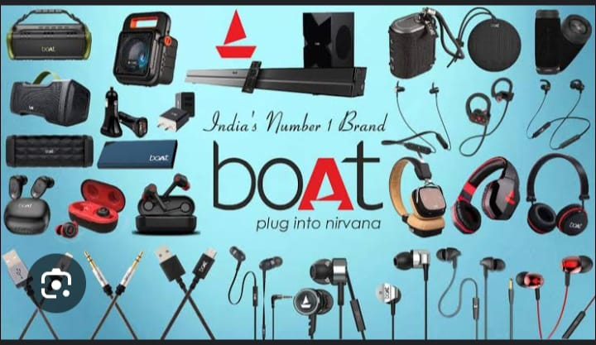

SEO and keyword research are essential for making your website visible to potential customers. Here's a breakdown:

SEO (Search Engine Optimization):

\* The Goal: Make your website rank higher in search engine results pages (SERPs) for relevant keywords.

\* Why It Matters: More visibility means more traffic to your site, leading to more potential customers.

\* Key Elements:

\* On-Page Optimization: Optimizing content on your website (using keywords, improving structure, etc.)

\* Off-Page Optimization: Building backlinks from other reputable websites to your site.

\* Technical SEO: Ensuring your website is technically sound for search engines (e.g., fast loading speed, mobile-friendly).

Keyword Research:

\* The Goal: Identify the words and phrases people use to search for information related to your business.

\* Why It Matters: Helps you create content that aligns with what people are searching for.

\* Key Steps:

\* Brainstorming: Start with keywords related to your industry and products/services.

\* Keyword Tools: Use tools like Google Keyword Planner, Ahrefs, or SEMrush to research keywords, their search volume, and competition.

\* Analyze Competitors: See what keywords your competitors are ranking for.

\* Long-Tail Keywords: Focus on longer, more specific phrases that have less competition.

\* Target Intent: Understand the user's intent behind a search (e.g., informational, transactional, navigational).

1. Keyword Research: Identify relevant keywords with good search volume and manageable competition.

2. On-Page Optimization: Use your keywords strategically in your website content (page titles, headings, descriptions, etc.).

3. Off-Page Optimization: Build backlinks from other high-quality websites.

4. Track Results: Monitor your website's ranking and traffic over time. Make adjustments to your SEO strategy as needed.

Remember: SEO is an ongoing process. Continuously research, update your content, and adapt your strategy to stay ahead of the curve.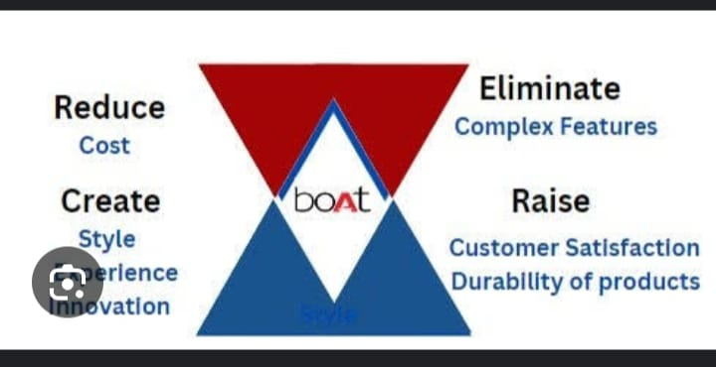

Content ideas and marketing strategies are key to attracting and engaging your audience. Here's a breakdown:

Content Ideas:

\* Blog Posts: Share valuable information, insights, and tips related to your industry or niche.

\* Videos: Create engaging videos that demonstrate your products or services, share tutorials, or provide entertainment.

\* Infographics: Visualize data and information in an eye-catching and easily digestible format.

\* Social Media Posts: Share updates, behind-the-scenes glimpses, and interactive content.

\* Email Newsletters: Provide valuable content and exclusive offers to your subscribers.

\* Case Studies: Showcase successful projects or customer stories.

\* Webinars: Host live online events to educate and engage your audience.

\* Podcasts: Create audio content that provides value and entertainment.

\* Ebooks and White Papers: Offer in-depth guides and resources on relevant topics.

Marketing Strategies:

\* SEO: Optimize your content for search engines to drive organic traffic.

\* Social Media Marketing: Promote your content and engage with your audience on social media platforms.

\* Email Marketing: Build an email list and send targeted content and offers to your subscribers.

\* Paid Advertising: Use platforms like Google Ads or social media ads to reach a wider audience.

\* Content Marketing: Create valuable and engaging content that attracts and retains your target audience.

\* Influencer Marketing: Partner with influencers in your niche to reach their followers.

\* Public Relations: Build relationships with media outlets and secure press coverage.

\* Affiliate Marketing: Partner with other businesses to promote their products or services in exchange for a commission.

Content creation and curation are essential for building a strong online presence and engaging your audience.

Content Creation:

\* Identify your target audience: Understand their interests, needs, and pain points.

\* Choose the right format: Consider blog posts, videos, infographics, social media posts, podcasts, etc.

\* Brainstorm compelling ideas: Think about topics that are relevant, informative, and engaging.

\* Create high-quality content: Ensure your content is well-written, visually appealing, and easy to understand.

\* Optimize for search engines: Use relevant keywords and phrases to make your content discoverable.

\* Promote your content: Share it across social media, email, and other channels.

Content Curation:

\* Identify valuable resources: Find relevant and interesting content from other sources.

\* Curate and share with your audience: Post links to articles, videos, and other content on social media or in your blog.

\* Provide context and commentary: Add your own insights and perspectives to the content you share.

\* Build relationships with other content creators: Engage with other creators in your niche and share each other's content.

\* Use content curation tools: There are many tools available to help you find, organize, and share content.

Remember:

\* Focus on quality over quantity: Create and curate content that is truly valuable to your audience.

\* Be consistent: Regularly create and share content to keep your audience engaged.

\* Track your results: Monitor your metrics to see what content is performing well and adjust your strategy accordingly.